A

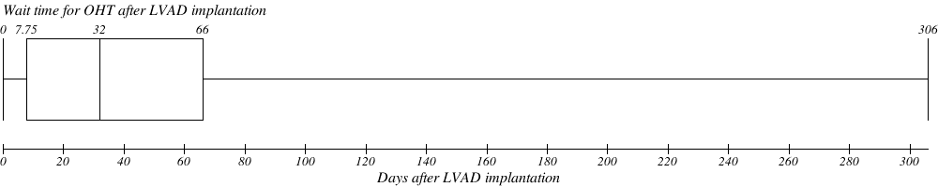

B

**Figure 1.** (A) Box-and-Whisker plot of wait time for OHT after LVAD implantation. (B) Comparison of percent mortality in hospitalized patients by wait time for OHT after LVAD implantation and no OHT after LVAD implantation. Percent mortality for each quartile was calculated as number of deaths per quartile by total number of patients per quartile. LVAD, Left Ventricular Assist Device